**Lab3: create a three tier architecture on aws cloud**

**Route 53**

**Auto scaling**

**Load balancer**

**Theory:**

Route 53:

Amazon Route 53 is a scalable and highly available Domain Name System (DNS) web service by AWS.Route 53 is often used in combination with Auto Scaling and Load Balancers to ensure that traffic is directed to healthy resources or regions with the lowest latency.

### Auto Scaling:

Auto Scaling is an AWS service that automatically adjusts the number of EC2 instances in response to traffic changes, ensuring that applications maintain performance and cost-effectiveness.

### Load Balancer:

A Load Balancer in AWS distributes incoming application traffic across multiple targets, such as EC2 instances, containers, or IP addresses, to ensure fault tolerance and high availability. A Load Balancer is essential for applications with unpredictable traffic patterns, such as social media platforms or SaaS applications, ensuring optimal performance and uptime.

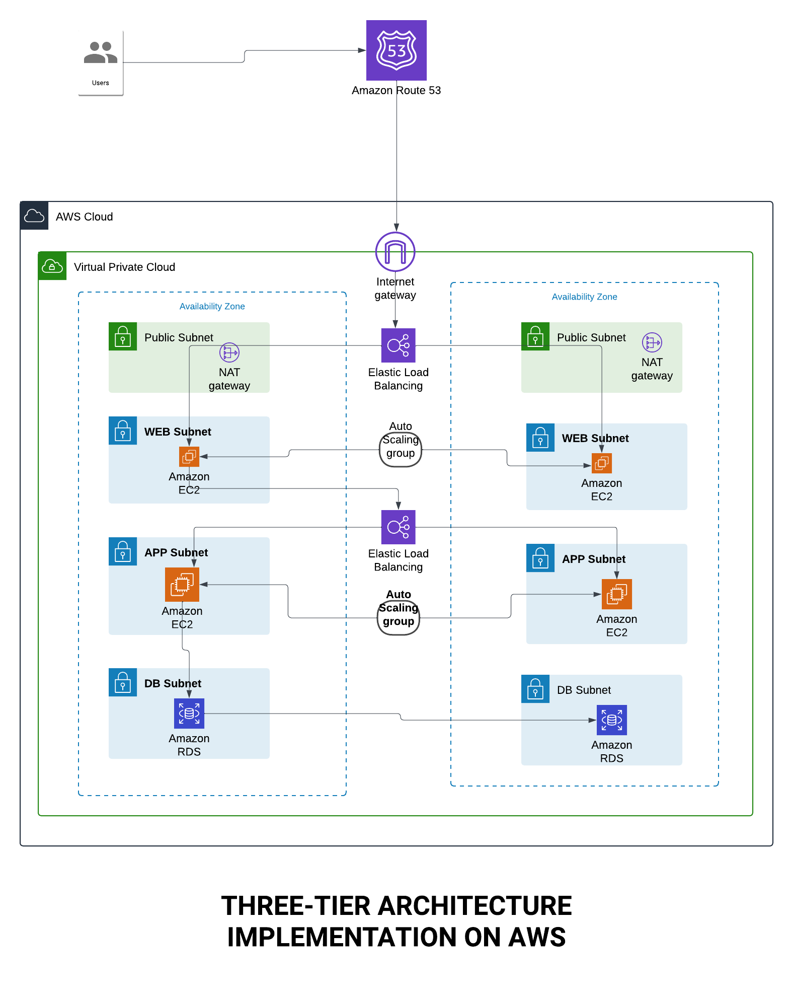

**Conclusion**we worked on designing a three-tier architecture diagram using Lucidchart, and it was a great learning experience! We dove into Route 53, Auto Scaling, and Load Balancers, understanding how they work together to create a system that's scalable, reliable, and efficient.

* Route 53 showed us how to manage domains and route traffic to the right resources.
* Auto Scaling taught us how to automatically handle changing traffic levels, keeping performance smooth without overspending.
* Load Balancers helped us distribute traffic evenly, ensuring no single resource gets overwhelmed.